

18955 North Memorial Drive, Suite 250
Humble, Texas 77338
P: 346-477-8700 F: 346-477-8701
Website: ArmstrongNeurology.com / Email: cnsneurology@aol.com

You have an upcoming appointment with Dr. James Armstrong

Date of Appointment:

Arrival Time:

Referred By:

For:

Please take the time to complete the enclosed forms. Bring your completed forms, along with your insurance card(s) to your appointment.

Also, if you have had any MRI or CT Scan performed, please make sure to bring a copy of the CD along with the report.

**If the forms are not completed and /or you are late for your appointment you will be rescheduled. Please give 24-hour notice of cancellation.**

Call us at the number above if you have any questions. Thank you!

18955 North Memorial Drive, Suite 250
Humble, Texas 77338
P: 346-477-8700 F: 346-477-8701
Website: ArmstrongNeurology.com / Email: cnsneurology@aol.com

Patient Information:

Patient Name: Sex:

DOB: Phone: Alt.#:

Address:

SSN #: Marital Status:

Emergency Contact: Phone:

E-mail Address:

Insurance Information:

Primary Insurance:

Policy Holder Name: Employer:

Policy #: Group:

Relation to Patient:

Secondary Insurance:

Policy Holder Name: Employer:

Policy #: Group:

I authorize Armstrong Neurology, PA to provide my insurance company any necessary information related to services rendered. I also authorize my insurance company to pay the amount due for services rendered directly to Armstrong Neurology, PA.

I understand that I am ultimately responsible for the payment of all charges resulting from services provided. I also understand that it is my responsibility to provide Armstrong Neurology, PA with up-to-date insurance and/or demographic information.

X Date:
(Signature of Patient or Legal Guaridan)

18955 North Memorial Drive, Suite 250
Humble, Texas 77338
P: 346-477-8700 F: 346-477-8701
Website: ArmstrongNeurology.com / Email: cnsneurology@aol.com

Acknowledgement of Receipt

Patient Name: Date:

Our Notice of Privacy Practices provides information about how we may use and disclose protected health information about you. It also provides information about your rights as a patient of our practice and whom you may contact at our office to ask questions about our policy practices.

By signing this form, you agree that you have had the opportunity to read our notice of privacy practices.

Armstrong Neurology, PA has permission to discuss my records with following people. If you do not want your records discussed with anyone other than yourself, please list " nobody".

Name Relationship to Patient

Patient Signature Date

18955 North Memorial Drive, Suite 250
Humble, Texas 77338
P: 346-477-8700 F: 346-477-8701
Website: ArmstrongNeurology.com / Email: cnsneurology@aol.com

PRACTICE POLICES

We require 2 or 3 days in advance to reschedule and cancel appointment or procedures in order for no fee to apply.

THESE ARE THE FEES:

Missing your (new patient) initial appointment $50

Missing your follow up appointment $25

Missing your procedures such as: EEG, AEEG and EMG $50

All Co-pays, coinsurance and / or past due balances must be collected at check in.

A family member or caregiver MUST accompany nursing home patient at all time.

Turn CELL phone OFF upon entering the office.

Children MUST be supervised at all times.

REFILLS: Call your pharmacy for refill requests to be faxed to our office. Please allow 48 hours for refill to be faxed back.

Date:
Patient Signature

18955 North Memorial Drive, Suite 250
Humble, Texas 77338
P: 346-477-8700 F: 346-477-8701
Website: ArmstrongNeurology.com / Email: cnsneurology@aol.com

Chart #: Referring Physician:

Date of consult: Primary care physician:

Medical history:

Name: Date of Birth:
Age: Circle one: Right handed Left handed
Height: Weight:
Address:
Phone: Alt. #:
Email Address:
Local Pharmacy:

In order to provide you with the best possible medical care, please take a few minutes to fill out this information in as much detail as possible.

What medical issue(s) brings you to the clinic today?

Please list all medical conditions:

1.
2.
3.
4.
5.
6.
7.
8.
9.
10.

Please list all prior operations:

1.
2.
3.
4.
5.
6.
7.
8.

18955 North Memorial Drive, Suite 250
Humble, Texas 77338
P: 346-477-8700 F: 346-477-8701
Website: ArmstrongNeurology.com / Email: cnsneurology@aol.com

Please list all medications that you are presently taking (including over-the-counter):
Include the dose and how many times a day you take each medication. You may attach a list if you wish.

1.
2.
3.
4.
5.
6.
7.
8.
9.
10.

Please list all medications that you are allergic to any the nature of the allergic reaction:

1.
2.
3.
4.
5.
6.
7.
8.

Social History:

Do you smoke: Are you ready to quit:
At what age did you start smoking: If so, how many pack a day:
If so, how long did you smoke regularly:
Why did you stop smoking:
Do you use chewing tobacco: What kind:
Do you drink, if so, how much on average:
Are you single or married:
How many biological children to you have?:
Do they have any medical conditions?
What is your occupation?:
What was your highest level of education?:

18955 North Memorial Drive, Suite 250
Humble, Texas 77338
P: 346-477-8700 F: 346-477-8701
Website: ArmstrongNeurology.com / Email: cnsneurology@aol.com

Family history:

Living? Age List any medical conditions (even if decreased)
(Or age lived to)
Father:
Mother:

List any medical conditions
Number of brothers and sisters:

Describe any neurological conditions that run in your family:

Review of Systems:

Please list any complaints that your presently have in any of the following areas:

How do you feel in general:
Describe your exercise program:
Do you typically get good sleep at night:
Head, eyes, ears, nose, throat:
Neck:
Lungs:
Heart:
Gastrointestinal:
Genitourinary:
Muysculoskeletal:
Extremities:
Skin:
Neurological:
Do you have stress or anxiety, if so, please describe:
Do you have any thoughts as to what could be causing your illness:

Additional comments:

18955 North Memorial Drive, Suite 250
Humble, Texas 77338
P: 346-477-8700 F: 346-477-8701
Website: ArmstrongNeurology.com / Email: cnsneurology@aol.com

Directions

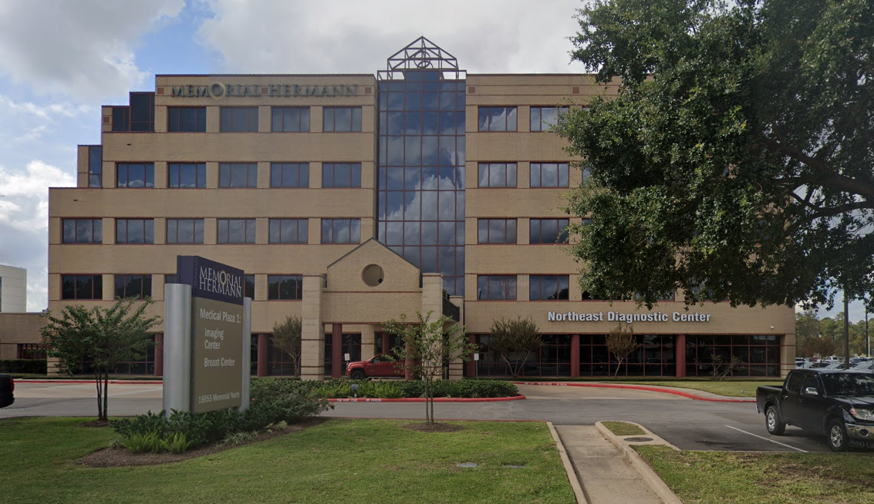

Directions from I-69:

- From I-69 North:
- Follow I-69 to 4th St/Eastex Freeway Service Rd in Humble. Take exit 147 from I-69
- Turn right onto Memorial Blvd
- We are located in the Memorial Hermann Medical Plaza 1 Building

- From I-69 South:
- Head North on I-69 HOV
- Turn Left onto McKay Dr.
- Turn Right onto W Memorial Dr.

AND YOU HAVE ARRIVED!!!!

